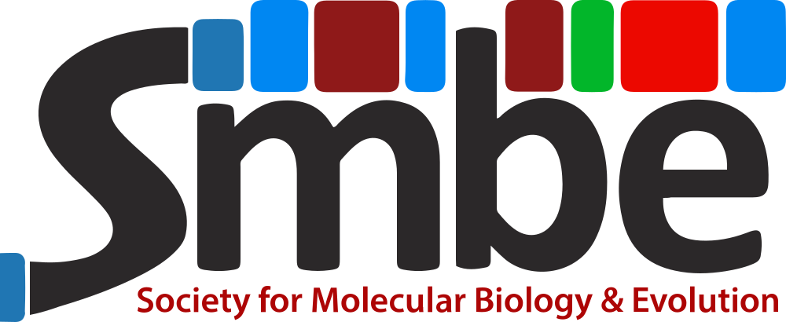

Social media guidelines (meetings)

v1.0 - April 2026
Pedro Andrade
Contact: smbe.socialmedia@gmail.com

Account information

Platform | Handle / Username | Link | Status
Bluesky | @official-smbe.bsky.social  @smbe-idea.bsky.social | https://bsky.app/profile/official-smbe.bsky.social  https://bsky.app/profile/official-smbe.bsky.social | Active; main short-form posting account  SMBE IDEA account managed by members of the SMBE IDEA Taskforce
Mastodon | @officialSMBE@ecoevo.social | https://ecoevo.social/@officialSMBE | Inactive
X | @OfficialSMBE | https://x.com/officialsmbe | Inactive
LinkedIn | n/a | https://www.linkedin.com/company/society-for-molecular-biology-and-evolution | Active; main long-form posting account
Facebook | OfficialSMBE | https://www.facebook.com/OfficialSMBE | Active; secondary long-form posting account
WeChat | @officialSMBE | n/a; QR code available through the following link:  https://academic.oup.com/smbejournals/pages/wechat | Active; secondary long-form posting account (posts in Chinese)

SMBE social media guidelines for meetings

Account creation and governance

For the general yearly/bi-yearly SMBE meetings, social media communication should be conducted primarily through the society’s main institutional accounts (see above). As the flagship SMBE event, this ensures continuity and visibility, leveraging the large number of followers these main accounts already have. The Local Organizing Committee (LOC) should liaise with the SMBE Social Media Manager or other personnel managing the society’s communication accounts.
For regional or satellite meetings sponsored by the society, the LOC may create dedicated social media accounts if deemed beneficial to promote the meeting. In these cases, account names or descriptions should mention sponsorship by the society (for example, by including the SMBE acronym in the handle or display name), to help maintain recognition of the society. However, each LOC can request assistance from the society in posting announcements and news from their event on SMBE’s main accounts (rather than using dedicated meeting accounts).

Posting responsibilities

The SMBE’s main accounts are managed by the society’s Social Media Manager; posting on these accounts should follow the general social media guidelines approved by the SMBE Council, which sets the types of content and the tone to be used during social media communication
For secondary accounts created by a LOC, the LOC is responsible for day-to-day management, including content creation and moderation; the LOC is advised, though, to consult with the society’s Social Media Manager to clarify posting objectives and a proposed calendar. Reposting of all LOC content from the Society’s main accounts is highly encouraged (please tag the society’s username and use the dedicated meeting hashtag to ensure visibility).

Visual style and branding

Each meeting is encouraged to develop a unique visual identity that reflects its scientific focus or location. This helps distinguish the meeting from other initiatives within the broader society calendar. At the same time, the society affiliation/sponsorship should remain visible: the SMBE acronym should be included in the logo and the main conference promotional materials. Other visual elements inspired by the society’s logo (e.g., the colored stripes, logo font) or the broader molecular sciences are encouraged to promote recognition.

Communication style

Conference-related posts should maintain a neutral, formal tone as the default; this is mostly relevant when posting announcements and other official updates (e.g., important dates, program, logistics). For posts during and after the conference, the communication style should shift to a more welcoming and community-oriented tone, while still maintaining professionalism and academic appropriateness. This shift in tone is expected to contribute to community engagement at a time when the SMBE is most exposed to conference participants.
At all times, communications should adhere to the SMBE Values Statement and Code of Conduct (https://www.smbe.org/code-of-conduct), remaining respectful and inclusive—particularly when highlighting individuals and interactions among the community, taking the opportunity when possible to highlight contributions from underrepresented groups.

Tagging of participants

When possible, posts naming speakers, organizing institutions, awardees, and other participants should have a tag linking to the participant’s page on the relevant social media platforms (for public social media, such as Bluesky or LinkedIn). Because this is one of the most important factors driving reach and engagement on our social media platforms, it is recommended that the person preparing posts spend some time searching for the speaker’s or institution’s accounts (but only tagging when identification can be confirmed with confidence). To facilitate this process, conference registration forms are encouraged to include an optional field for participants to provide their social media handles.

Photographic content

Because scientific meetings are public professional events, it is generally acceptable to take and share photographs of participants taken during public sessions and social events. Nevertheless, if a participant requests that a photograph featuring them is removed, the social media manager should do it promptly. Photos featuring participants should focus on professional activity and avoid misrepresentation—the selected content must consider inclusivity and respectful representation of the participants.
Photographs of scientific content (talk slides or posters) should be restricted to general or non-identifiable content (e.g., title slides, acknowledgments, generalistic images, publicly shared information). More specific content should be shared with explicit permission from the authors. For poster sessions, photos may be taken from a distance to convey the event without focusing on individual poster content; close-up images of data/plots or other results should be shared with the presenting author’s permission.

Hashtag use

Each meeting should create a unique hashtag at the start of the communication cycle, to be included in all posts before, during, and after the event to help connect posts made by participants. For the general meetings, a consistent naming convention should be used (e.g., #SMBE2026, #SMBE2027, …). Regional or satellite meetings are free to create their own hashtags; these should, in any case, be concise and refer to the meeting’s acronym and the year. Excessive hashtag use should be avoided (a maximum of three per post on most platforms).

Accessibility

To ensure accessibility to the broadest audience possible, supporting the SMBE’s commitment to inclusion, managers of social media accounts are encouraged to follow best practices when posting, including adding alternative text (alt text) to images (for users with screen readers or poor vision), using high-contrast visual designs, and avoiding conveying essential information through color alone (for color-blind users), or using captions for videos (to aid those with hearing impairments).

Moderation

Online interactions related to SMBE-sponsored meetings should be considered an extension of the meeting environment; they are therefore subject to the SMBE Values Statement and Code of Conduct. The managers of the social media accounts should, to the best of their ability, monitor comments and interactions on the platforms they are overseeing (e.g., comments on their accounts' posts, or interactions using the official meeting hashtag).
If the organizers or Social Media Manager detect any inappropriate comments or other harmful content, the incident should be documented and presented to a Council representative, so that an official coordinated response is prepared before further action is taken.

Promotion of other SMBE initiatives

Whenever possible, SMBE-affiliated meeting organizers should leverage opportunities to promote broader society initiatives, including the SMBE journals (Molecular Biology and Evolution and Genome Biology and Evolution, other SMBE meetings (either general, regional, or satellite meetings), or other initiatives (e.g., IDEA Task Force initiatives). One suggested mechanism for this is to use slides during presentation breaks to show some of this information. LOC representatives can inquire with the SMBE Social Media Manager to ask for specific materials.

SMBE Values Statement and Code of Conduct

Social media activity on the main society accounts and dedicated meeting accounts must align with the SMBE Values Statement and Code of Conduct. Meeting organizers responsible for social media are expected to contribute to an inclusive and respectful environment in all communications and to ensure that all official meeting communication channels reflect these principles. These policies should be clearly accessible on conference websites and communicated to participants. Please read the full updated version of these statements here: https://www.smbe.org/code-of-conduct

Quick operational checklist

Before announcing the meeting
☐ Email or virtual meet with SMBE Social Media Manager to discuss meeting needs and objectives
☐ Confirm whether the meeting will use the main SMBE account or create a secondary account
☐ Define official conference hashtag
☐ Confirm visual branding elements (logo use, color scheme)
☐ Add optional social media handle field to registration form
☐ Draft “Save the date” post

Before opening abstract submissions
☐ Prepare “Call for symposia” post
☐ Prepare “Call for abstracts” post
☐ Prepare “Registration” post
☐ Schedule reminder posts

Before the meeting
☐ Announce program availability
☐ Announce keynote speakers
☐ Highlight symposia sessions (organizers and speakers)
☐ Share venue and logistics information
☐ Prepare “Sponsors” post

During the meeting
☐ Post daily highlights
☐ Tag speakers (when appropriate)
☐ Repost user posts to increase engagement
☐ Monitor comments for moderation issues

After the meeting
☐ Post “Thank you” end-of-meeting message and meeting summary
☐ Prepare “Save the date” for next meeting

Sample social media calendar for SMBE-affiliated meetings
This is an example baseline calendar. Please adjust as needed for each event.

Content | Description | Posting schedule | Notes
Save the date | Initial announcement of conference dates and location | First announcement, when the basics are set | Include basic conference details and link to the website
Call for symposia | Announcement inviting proposals for symposia sessions | As soon as call opens | Include deadline and submission details
Call for abstracts | Announcement of abstract submission opening and symposia topics | As soon as call opens | Include deadline and submission link
Abstract deadline reminder | Reminder of upcoming submission deadline | 1 week before abstract deadline | Final call 1-2 days before the deadline
Award applications | Announcement of conference-related awards (e.g., travel grants, student prizes) | As soon as call opens | Include deadline and instructions
Registration open | Announcement that participant registration is open. Include early-bird details | As soon as call opens | Include deadline and registration link
Registration reminder | Reminder of registration deadline | 1 week before registration deadline | Final call 1-2 days before the deadline
Keynote speakers (series) | Posts introducing keynote speakers (one post per speaker), including affiliation and title of presentation | Throughout the registration/submission periods, repeat 1/2 months before meeting | Tag speaker and affiliations when possible
Program available | Announcement that the preliminary or final program is available online | As soon as it is known | Include links to the full program
Symposia posts (series) | Posts highlighting confirmed symposia topics (one per symposia, if possible), building up to the meeting | Throughout registration/submission period; repeat 1/2 months before meeting | Tag organizers and speakers when possible
Venue | Introduction to conference venue (city, institution, or conference center) | 2 months before | Include links to "Venue" section on website
Travel and logistics | Reminder about travel tips, visa information, or local transport | 1 month before | Include links to "Venue" section on the website
Sponsors and partners | Recognition of sponsors and supporting organizations | 2–4 weeks before | Repeat post on first day of conference. Tag sponsors.
Countdown post | Reminder that the conference is approaching | 10 days before | Repeat a similar post 2 days before
SMBE Code of Conduct | Reminder of SMBE Values Statement and Code of Conduct | 3 days before | Link to SMBE website

Content | Description | Posting schedule | Notes
Welcome message | Welcome message celebrating the start of the meeting | Day 1
On-site registration reminder | Reminder about registration desk hours or check-in procedures | Day 1 | Include links to "Venue" section on the website
Daily conference highlights | Posts summarizing key sessions, talks, or other meeting moments | Days 1,2, ...n | Prioritize photos over poster-like graphics. For short-form social media (Bluesky, Mastodon), post frequently during the day; for long-form platforms (LinkedIn), only 1-2 times per day
Keynote speakers live | Short posts during major sessions or keynote talks (if feasible) | Days 1,2, ...n | Prioritize photos over poster-like graphics. Tag speakers when possible
Social events | Reminder of locations and dates for social activities | Day of the social event | Prioritize photos over poster-like graphics
Award ceremony | Announcement and photos of award presentations | Final day of conference | Prioritize photos over poster-like graphics. Tag awardees when possible
Last day celebration | Long “thank you” type of post, acknowledging participants, speakers, sponsors, and organizers | Final day of conference | Prioritize photos over poster-like graphics
Post-Conference Wrap-Up | Summary of conference highlights, participation, and key themes | Within 1 week after | When possible, the message should be written by the LOC
Save the date (next year's event) | Announcement of next meeting location and dates (if a follow-up is known) | 1–2 weeks after

